Week 1: January 23, 2024
- Satellite
  - Parts ordered for experiment
  - Working on onboarding doc

Week 2: January 30, 2024
- Satellite
  - Attitude control:
    - Deliverable – bill of materials and timeline for test rig
- Comms
  - Computer ordered

Week 3: February 6, 2024
- Satellite
  - Experimental:
    - Currently waiting on parts, experimental method developed
    - NEED: EE or anyone available to build the circuit for thermocouple interfacing and data collection
    - Timeline: complete by end of february
  - Attitude Control
    - Plan of action: 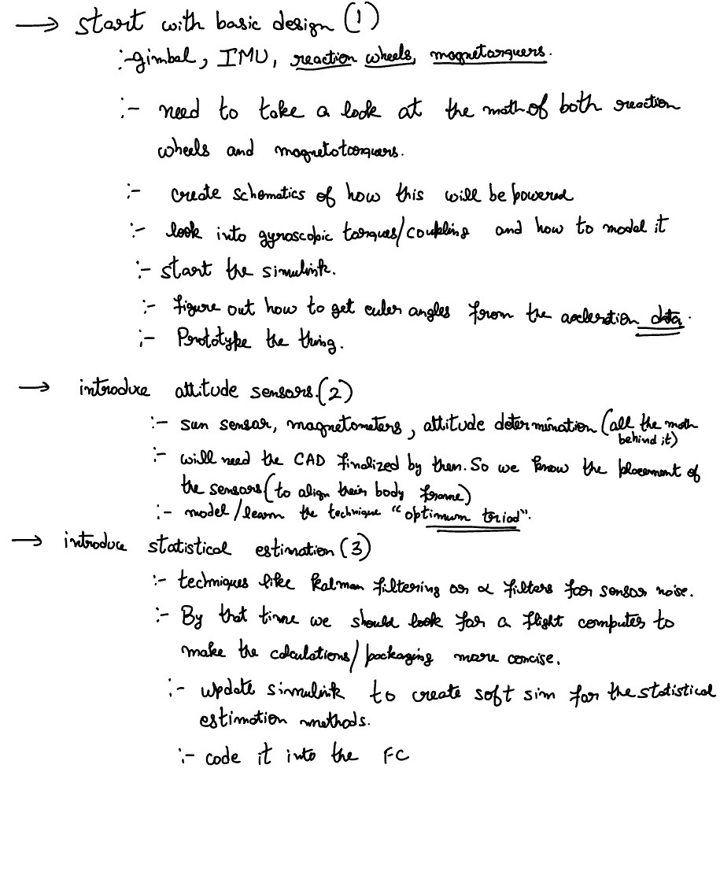
    - Adin, Daniel, Oscar working on CADing a gimbal
    - 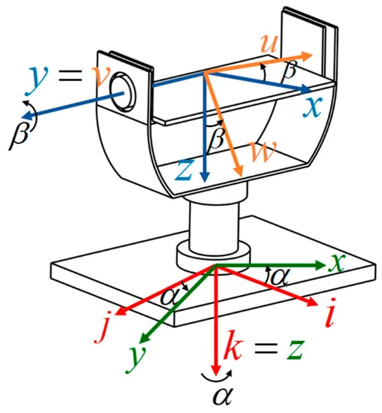

- Comms
  - Computer received, working on installing linux, able to receive signals?
  - Can’t transmit without a radio license!
    - Potentially get radio licenses for people on comms team.
  - Gaudi working on tracking/supporting Jay with comms

Week 4: February 13, 2024
- Attitude Control
  - Updated BOM
    - Complete gimbal before ordering parts to ensure everything will fit together
  - Working on mathematical model
    - How the change of momentum of reaction wheels changes spin of spacecraft
  - Magnetorquer vs reaction wheel.. We are neglecting magneto
  - Planning on completing simulink model within next month
  - Speak to mike about fabrication/ modeling
  - Potentially switching from 3D printed gimbal to PVC pipe gimbal
    - PVC may not be best option …
    - Potentially outsourcing gimbal
- Experimental
  - Most parts arrived
  - Working on DAQ circuit
  - Thinking about safety precautions for thermal experiment inside vacuum
    - For example, are we leaving the arduino inside the vacuum? How would we re-establish the vacuum seal if we fed it outside of the chamber? Does this introduce a potentially dangerous aspect to our system?
    - GOAL: complete set up before the end of Feb.
- Comms
  - Documentation for SDR: SDR Setup
  - Radio on satellites/ interacting with data/ chips have pre-integrated microcontrollers
  - Modeled 2 DOF antenna actuator
    - Think about choosing motors/ physical design
    - Antenna comes with mounting – planning on redesigning
- Power System
  - Solar panels for power/ solar energy also being absorbed by e-paper
  - Beginning research
- Look into building CUSLI website/ fundraising. Host through cooper??
  - Notion website, other cooper clubs use this!! (internal vs external)
    - Newsletter (monthly?)
    - Reach out to GE?? Other companies??
  - LETS DO THIS !!!! BY NEXT WEEK!!!
- Improving CUSLI
  - Improve onboarding
  - Get that lab space hehe
  - Visibility to new students (long term)
    - Goals aren't defined by competition/ we present a real world engineering problem
  - Hosting events/ speakers
  - Long term plans … after thermal, then what?
    - Using thermal problems outside of space application?
    - Brainstorming new potential missions

Week 5: February 20, 2024

Week 6: February 27, 2024

Week 7: March 5, 2024
- New Lab Space!!
- Attitude Control:
  - Decided to use exclusively magnetorquers
  - working on Simulink Model
  - Finalizing mathematical model
- FM Radio connection established 😎

Week 8: March 12, 2024
- No meeting

Week 9: March 19, 2024
- No meeting– Spring Break

Week 10: March 26, 2024

